Mini Project
- CREATE TABLE playlists ( playlist_id INT AUTO_INCREMENT PRIMARY KEY, user_id INT, name VARCHAR(150), created_at DATETIME, FOREIGN KEY (user_id) REFERENCES users(user_id) );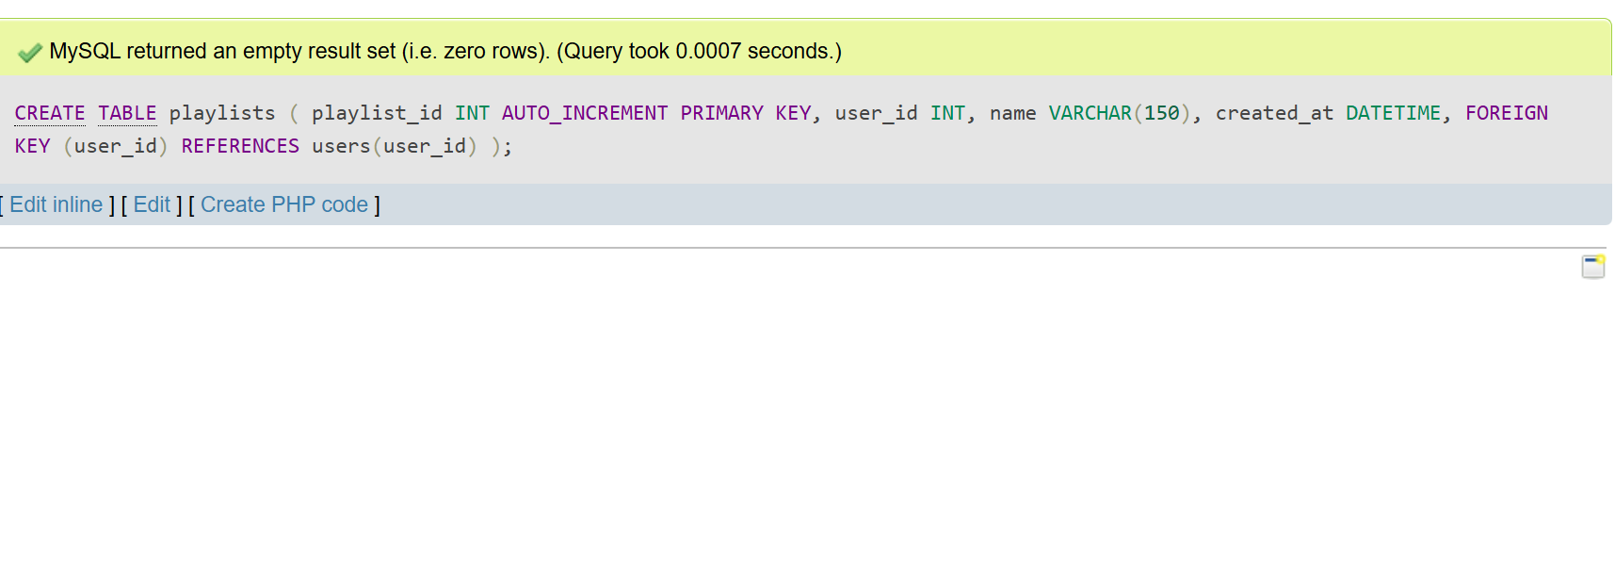
- INSERT INTO playlists (user_id, name, created_at) VALUES (1, 'Workout Mix', '2024-06-01 07:30:00'), (2, 'Chill Vibes', '2024-06-10 21:00:00'), (3, 'Top Hits', '2024-06-15 12:00:00');
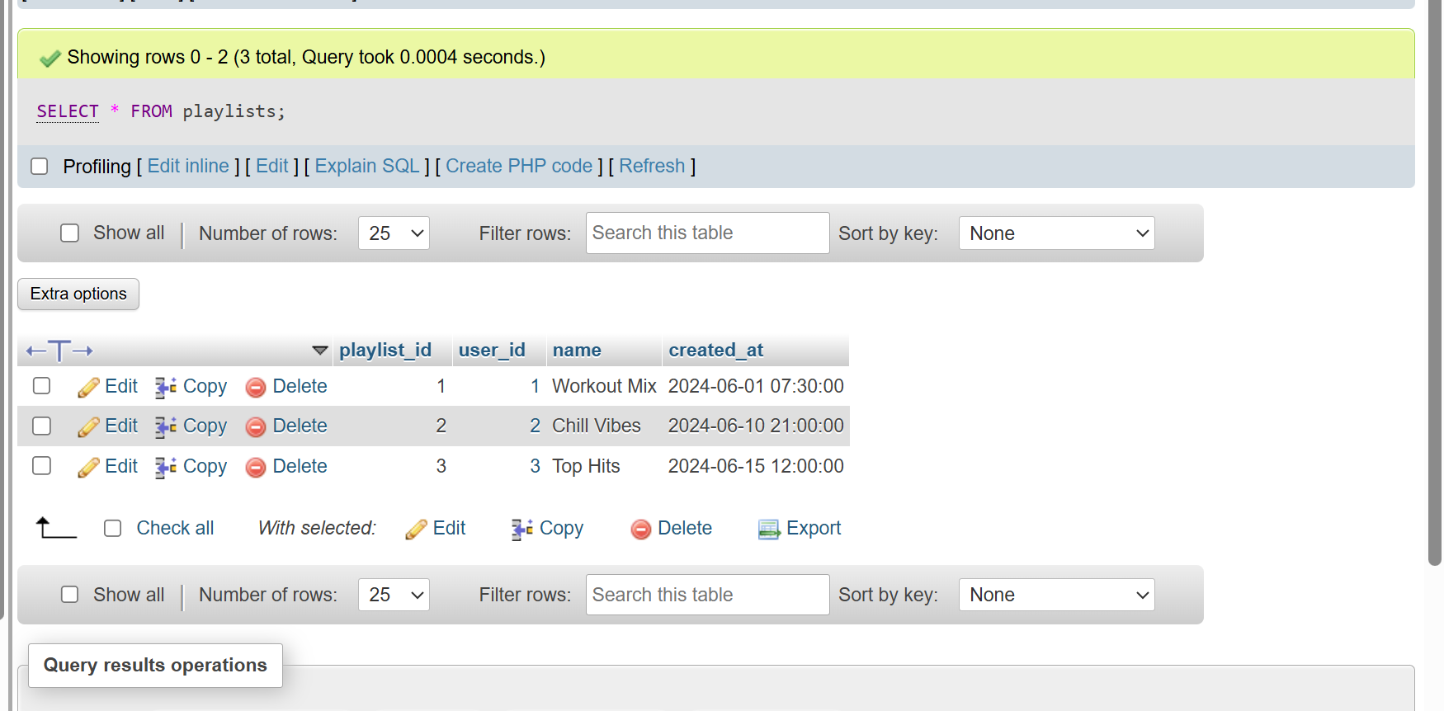

- UPDATE playlists SET name = 'Evening Chill' WHERE name = 'Chill Vibes' AND user_id = 2;
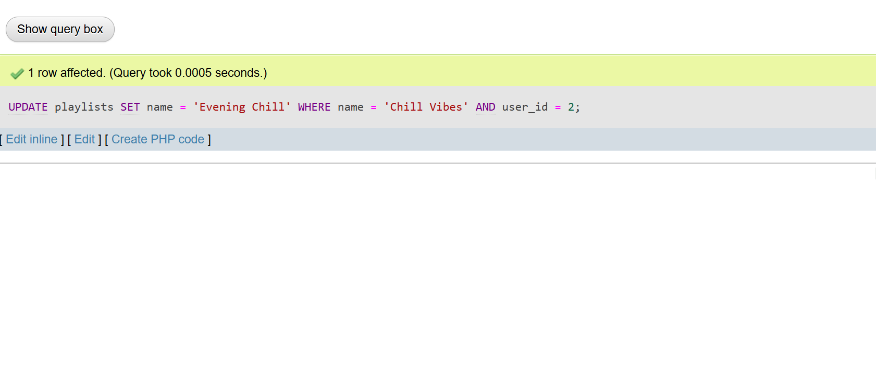
- DELETE FROM playlists WHERE name="Workout Mix" AND user_id = 1;
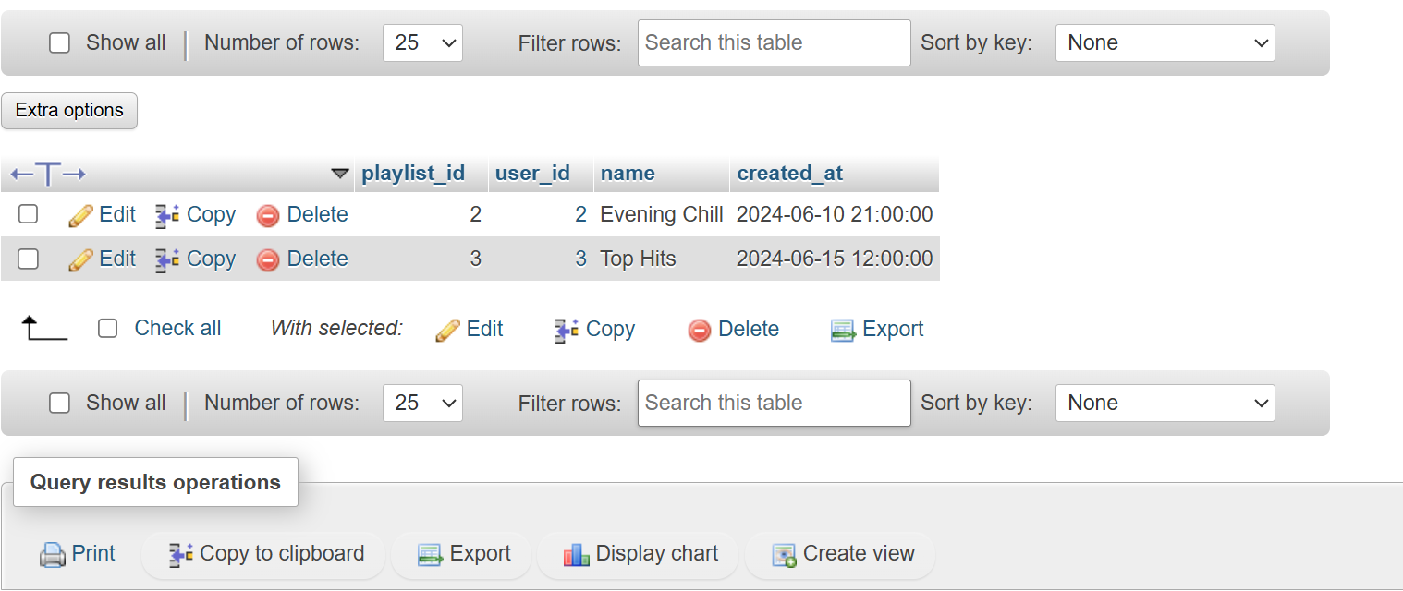

- CREATE PROCEDURE GetMonthlyPlaylistCount( IN p_user_id INT, IN p_month INT, OUT p_count INT ) BEGIN SELECT COUNT(*) INTO p_count FROM playlists WHERE user_id = p_user_id AND MONTH(created_at) = p_month; END;
